Lab Learning Objectives Addendum: Squid & Clam – Mollusks
Be able to ID the following structures AND know the function of each.
Please note: depending on the preservation state of the animal, you may OR MAY NOT find all the structures during the actual dissection BUT you can definitely find each structure in the zoology lab manual pdf colored handout!

Mollusks are bilateral, lophotrochozoans, that are triploblastic, protostomes, and possess a true (but greatly reduced) coelom. In most mollusks the coelom is greatly reduced and limited to a small cavity around the hearts, and sometimes around parts of the gonads and intestines, and kidneys.

Squid
External anatomy
Please reference the Zoology lab handout pdf for Mollusca – Table 11-3 for structure and function list
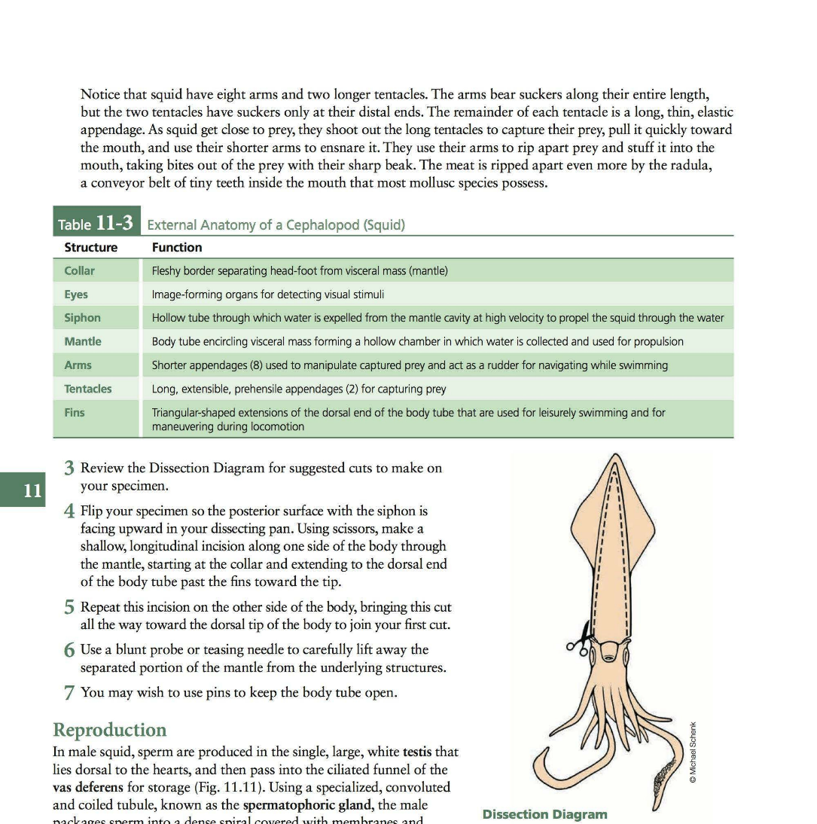
- Arms (modified foot – eight)
- Tentacles (modified foot – two)
- Eyes
- Beak
- Siphon (funnel)
- Mantle
- Fin
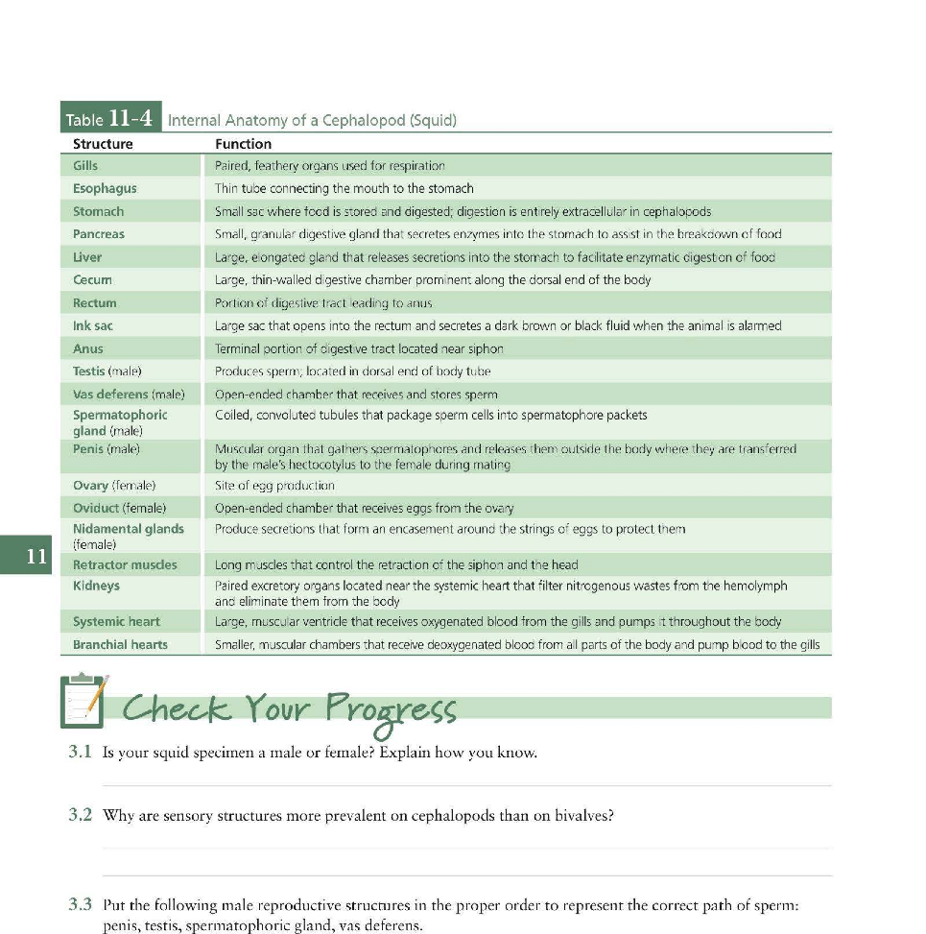
- Collar

Internal anatomy
Please refer to the zoology lab handout pdf Table 11-4 for structure and function list
- Visceral mass
- Gills
- Esophagus
- Stomach
- Rectum
- Anus
- Retractor muscles
- Pen (chitinous shell remnant)
- Gonad (identify as ovary or testis)
- Nidamental gland (female only)
- Ink sac
- Systemic heart (1)
- Brachial hearts (2)

Clam
Please refer to zoology lab handout pdf Mollusca Table 11-2 for structures and functions list
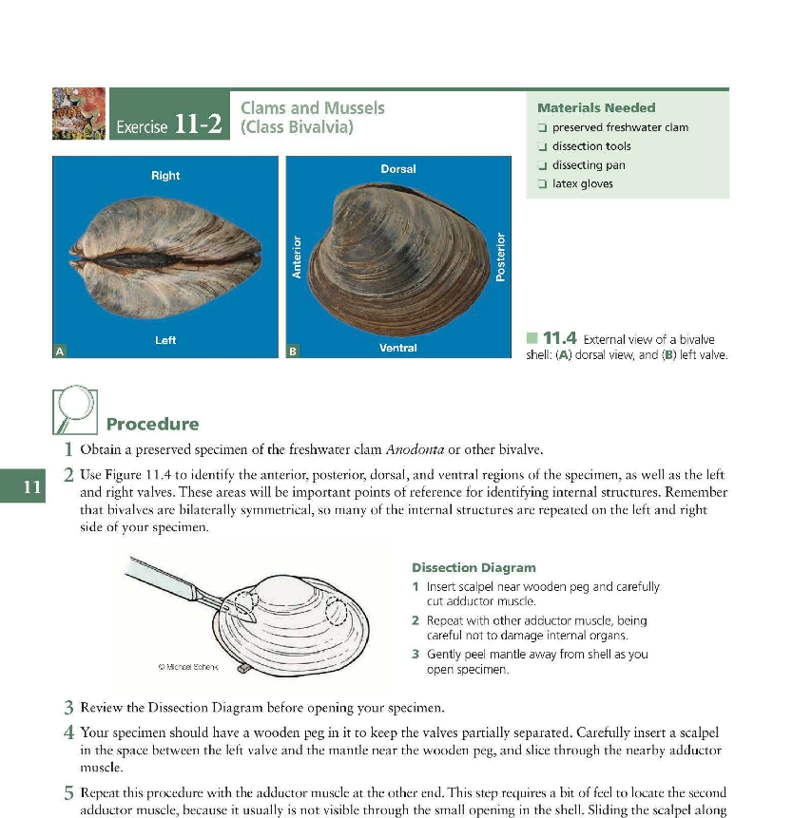
External anatomy
- Umbo – the umbo always points towards the anterior of the animal (see figure)
- Shells (right & left)

Internal anatomy
- Anterior adductor muscles
- Posterior adductor muscles
- Incurrent siphon
- Excurrent siphon
- Gills
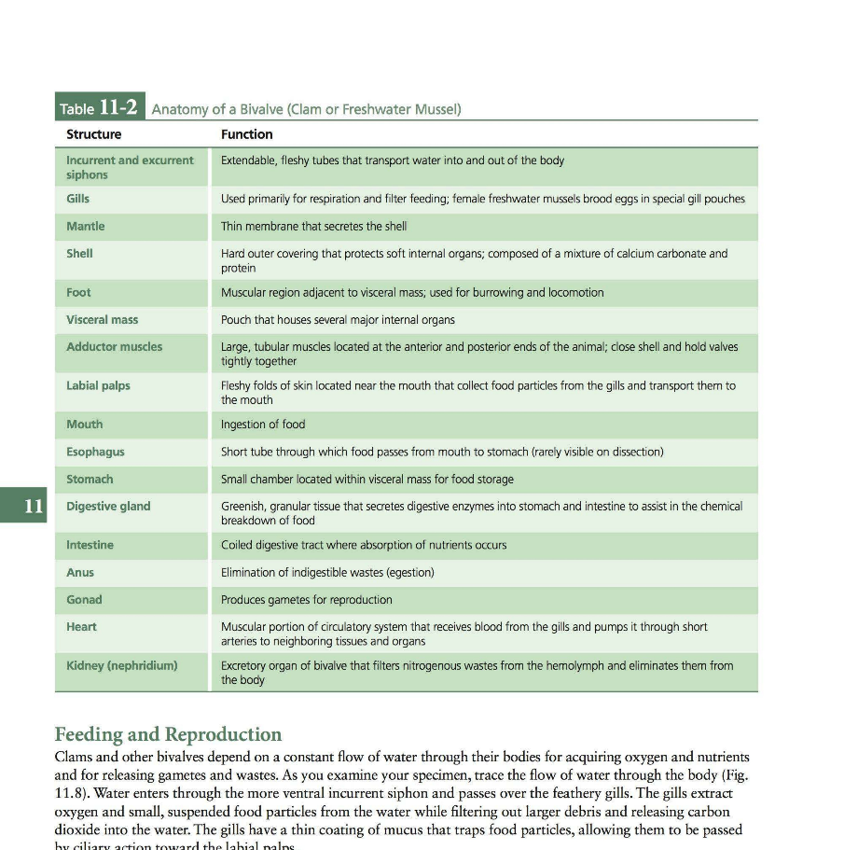
- Foot
- Mantle
- Visceral mass
- Mouth
- Stomach
- Labial palps
- Esophagus
- Stomach
- Digestive gland
- Intestine
- Anus
- Gonads (check species info: hermaphroditic OR separate sexes aka gonochoric?)
- Heart (1)
- Kidney

